Сохранить
try
{
this.Validate();
this.departmentBindingSource.EndEdit();
this.departmentTableAdapter.Update(this.businessTripDataSet);
departmentBindingSource.MoveLast();
MessageBox.Show("Сохранить изменение?", "Сообщение", MessageBoxButtons.YesNo);
}
catch (Exception ex)
{
MessageBox.Show(ex.Message);
}
Поиск(фильтр)
if (dataGridView2.DataSource ==departmentBindingSource)
{
departmentBindingSource.Filter = " [Department] LIKE'" + textBox1.Text + "%'";
}
Поиск с выделением ячеек(работает с combobox(для этого свойство столбца FlatStyle поставить Flat))
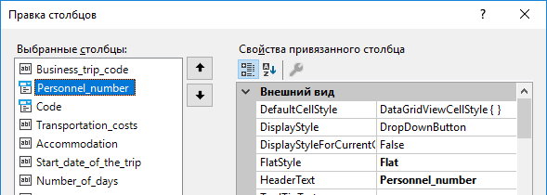
try
{
string value = textBox2.Text;
for (int i = 0; i < dataGridView1.ColumnCount; i++)
{
for (int j = 0; j < dataGridView1.RowCount; j++)
{
dataGridView1.Rows[j].Cells[i].Style.BackColor = Color.Empty;
string vale = dataGridView1[i, j].EditedFormattedValue.ToString();
if (vale == value)
{
dataGridView1.CurrentCell = dataGridView1[i, j];
dataGridView1.Rows[j].Cells[i].Style.BackColor = Color.Red;
}
}

Запрос с параметром
SELECT CONCAT_WS(' ', Employees.Surname, Employees.Name, Employees.Patronymic) AS SNP//для отображения ФИО, Locality.Locality, (Trip.Transportation_costs + Trip.Accommodation + Locality.Daily_costs) * Trip.Number_of_days AS Costs
FROM Employees INNER JOIN
Employees AS Employees_1 ON Employees.Personnel_number = Employees_1.Personnel_number INNER JOIN
Job ON Employees.Job_code = Job.Job_code AND Employees_1.Job_code = Job.Job_code INNER JOIN
Trip ON Employees.Personnel_number = Trip.Personnel_number AND Employees_1.Personnel_number = Trip.Personnel_number INNER JOIN
Locality ON Trip.Code = Locality.Code
WHERE (CONCAT_WS(' ', Employees.Surname, Employees.Name, Employees.Patronymic) = @ВведитеФамилию)
После выполнения запроса
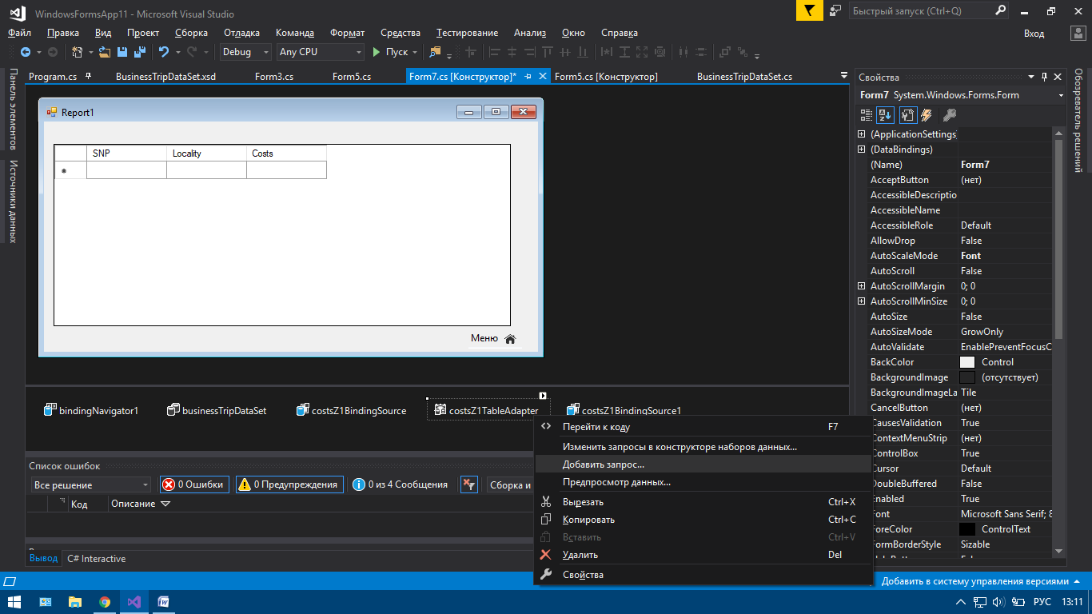
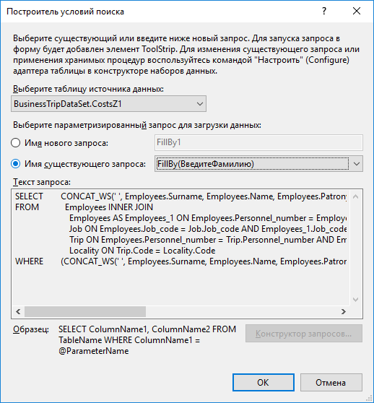
Несколько данных в ячейке
dynamic Сотрудник;
Сотрудник = businessTripDataSet.Employees.Select(V => new
{
V.Personnel_number,
ФИО = string.Format("{0} {1}.{2}.", V.Surname, V.Name.First(), V.Patronymic.First())
}).ToList();
personnelnumberDataGridViewTextBoxColumn.DataSource = Сотрудник;
personnelnumberDataGridViewTextBoxColumn.DisplayMember = "ФИО";
personnelnumberDataGridViewTextBoxColumn.ValueMember = "Personnel_number";

Переход по формам
Form6 d = new Form6();
d.Show();
this.Close();

Запрос на количество проданного товара
SELECT Товар.Название_товара, SUM(Заказы.Количество_товара) AS Expr1
FROM Товар INNER JOIN
Заказы ON Товар.ID_товара = Заказы.ID_товара
GROUP BY Товар.Название_товара
Сортировка по возрастанию
this.dataGridView1.Sort(this.dataGridView1.Columns[1], ListSortDirection.Ascending);

Сортировка по убыванию
this.dataGridView1.Sort(this.dataGridView1.Columns[2], ListSortDirection.Descending);

